# Lab 9: E-mail Server with DNS and DHCP Service and FTP Server.

## Topology Diagram

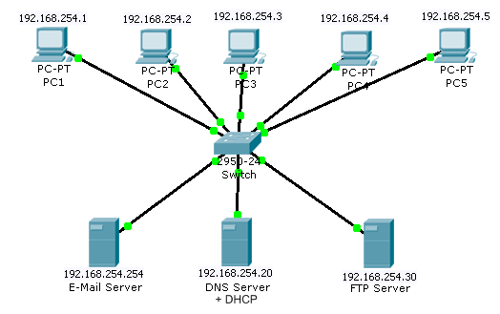

## Learning Objectives

Upon completion of this lab, you will be able to:

* Configure an e-mail server
* Configure the host computers for e-mail service
* Download and configure **Simple DNS** on a PC to provide both DNS and DHCP services.
* The DHCP Server’s address pool to be used is 192.168.254.1 to 192.168.254.18
* Capture and analyze e-mail and DNS communication between the host computer and a mail server using Wireshark.
* Configure a FTP server if time allows using FileZilla Server.

**This lab is a continuation and expansion of Lab 7 e-mail services lab.**

**Step 1**

Ensure you have this lab document, Wireshark, FileZilla Client, FileZilla Server, Simple DNS, hMailserver and Thunderbird available on your local C: drive.

Step 2

Remove the Win 7 client PC’s form the college network having downloaded any required software and lab instructions to the local drive. Go to the IP settings and ensure that you obtain an IP address automatically and remove any IP addresses of DNS servers.

Note : The PC that is running Simple DNS must start the service running before removing it from the Internet – it requires a ‘Free License’ check-in from the vendors site before you can run it.

**Step 2**

Configure the **hmailserver** and the **Thunderbird** e-mail clients as you did last week but this time use the name *mailserver.hcit.com* instead of the server’s IP address as both the POP3 and SMTP server in the Thunderbird client settings.

**Step 3**

Having installed and started the DNS service on the DNS server remove it from the college network and statically set its ip address to 192.168.254.20/24.

Create a new **primary forward zone** called *hcit.com*

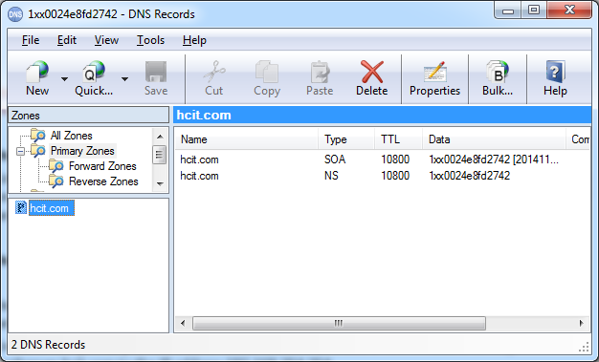

and add a new **A Record** to map *mailserver.hcit.com* to the IP address 192.168.254.254.

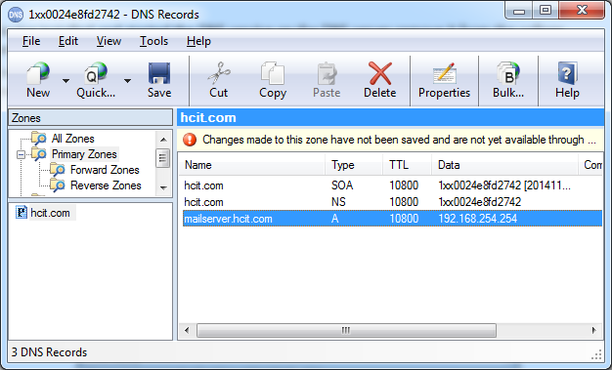

## Step 4

## On the Simple DNS Tools\Options menu select Plug-ins and select DHCP.

## 

## Work through the options available to setup the required address pool and advertise the ip address of the DNS server to requesting clients.

## Step 5

## Launch Wireshark and see if you can observe DNS packets and e-mail packets.

## Step 6

## If time allows – configure a machine on the LAN to act as a FTP server – give it a hostname and use the DNS server to resolve this for FTP clients. Use FileZilla Server for this purpose.

## Tear down your network at the end of the lab session and ensure all machines can access the college network and the internet before leaving the lab.